**Software Requirements Specification**

**Check Inn Hotel Management System**

Prepared By: Group 2

Date: April 1st, 2024

Stakeholders Involved: Group 4

**1. Introduction**

This Software Requirements Specification (SRS) document outlines the specifications and requirements for the Check Inn #1 Hotel Management System, a comprehensive digital solution designed to improve operational efficiency, guest satisfaction and business needs. The purpose of this document is to allow various stakeholders to fully understand the requirements, including functional and non-functional ones, as well as various constraints and assumptions.

This SRS breaks down into a number of important sections, each of which is devoted to providing in-depth analysis of a certain system aspect:

**Overall Description**

* This section gives a high-level overview of the Check Inn #1 Hotel Management System, including its goals, objectives, scope, and the value it hopes to bring to the Check Inn chain of hotels.

**System Features(Functional and Non-Functional Requirements)**

* This section delves into the specific features and capabilities of the Check Inn #1 Hotel Management System, encompassing both functional requirements that define the system's behavior and non-functional requirements that describe its quality attributes.

**Data Requirements (Data Dictionary and Logical Data Model)**

* The data requirements section provides a comprehensive overview of the data utilized within the system. It includes a data dictionary detailing the definition, structure, and attributes of all data elements, ensuring clarity and consistency in data management.

**External Interface Requirements (User Interface and Wireframes)**

* External interface requirements describe how the system interacts with external entities, particularly users.. This section includes the user interface wireframe and communication interface that interacts with users.

**Quality Attributes (Usability, Performance, Security, Safety)**

* Quality attributes define the characteristics and properties of the system that contribute to its overall quality and effectiveness. This section addresses key attributes such as usability, performance, scalability, data security and safety.

**Internationalization**

* The internationalization aspect considers the system's ability to adapt and support users from diverse linguistic and cultural backgrounds. This involves designing the system to accommodate various languages, cultural norms, and regulatory requirements, enabling global accessibility and usability.

This document is designed to be a comprehensive reference for all parties involved in the development and implementation of the Check Inn #1 Hotel Management System. By detailing the system's intended features, requirements, and specifications, stakeholders can align their expectations, contribute effectively to the system's development, and ensure its successful deployment and utilization within the Check Inn hotel chain.

**1.1 Purpose**

The purpose of this document is to provide all stakeholders with a common understanding of the goals and specifications of the Check Inn #1 Hotel Management System by clarifying its requirements, such as functions, operational needs, system interactions, and performance metrics.

Target Audience includes:

* Developers: Software developers can use this document as a reference to design architecture and implement functionality. The document outlines all functional and non-functional requirements of the system, including data structures, system interfaces, etc.
* Project Manager: Project managers can use this SRS to understand the scope, resource requirements, and deliverables of the system. Project managers can refer to this document to plan, execute and monitor the development process to ensure alignment with project objectives.
* Marketers: Marketing professionals can use the insights in this document to understand the system's capabilities and benefits. This document can help marketers create more effective marketing strategies and materials that emphasize the system's benefits to potential users and stakeholders.
* Users (hotel staff and managers): The SRS provides a clear introduction to the main functions of the system. Hotel employees can learn the functions and adapt to the new system faster.
* Quality Assurance Engineer: Quality Assurance Engineers can use this document to define the criteria for system validation, including test scenarios, expected results to ensure that the system meets all specified requirements.
* Documentation Writers: Documentation writers can use this document as a reference to create user manuals, help guides, and training materials.

**1.2 Document Conventions**

This Software Requirements Specification (SRS) document uses specific conventions to distinguish various types of information, making it easier for readers to navigate and interpret the document. The following are the conventions used in this document:

* Bold text: Bold text is used for titles, subtitles, and any terms that need emphasis in the text.
* Italicized text: Italicized text is used to highlight new terms or phrases, emphasize a particular point, or indicate a quotation or reference.
* Numbered List: A numbered list is used to present a series of steps, requirements, or items that need to be followed in a specific order.
* Bulleted Lists: Bulleted lists are used to enumerate items, features, or points that do not require a specific order.
* Highlight: Text highlighting is used to draw attention to key information, warnings, or important notes in a document. Highlighted text should be considered priority information that requires special attention.
* [REQ-ID]: Each requirement in the document is identified with a tag following the format [REQ-ID], where "ID" represents a sequence number (e.g., [REQ-1], [REQ-2]) and sub- Serial number (e.g. [REQ-1-1).

**1.3 Project Scope**

The Check Inn #1 Hotel Management System is a comprehensive platform that aims to improve guest satisfaction, optimize operations, and offer valuable business insights to the Check Inn hotel brand.. The creation of this system is aligned with the company's overarching objective, which is to leverage Internet technology to boost operational effectiveness and service quality in the hotel sector while seizing the chance to foster commercial expansion.

**1.3.1 Purpose and Relation to Corporate Goals:**

Integrating diverse operational hotel administration components onto a single platform is the primary goal of the Check Inn hotel brand. The development of the system is intended to optimize internal procedures, promote data-driven decision-making, and enable smooth communication between visitors and hotel services. When this system is finished, the business will be in a better position to lead the hospitality sector.

**1.3.2 Relation to Business Objectives and Strategies:**

The company's business plan, which aims to increase competitiveness, improve growth, and increase market share, heavily relies on the system. Through enhanced operational efficiency and guest service, the system contributes to revenue growth, cost reduction, and improved brand perception.

**1.3.3 Scope of the Software:**

The Check Inn #1 Hotel Management System encompasses several key modules and features designed to address specific needs within the hotel's operational and guest service domains:

* Online Booking and Reservation Management: Facilitates easy and efficient guest booking experiences, with real-time availability updates and automated reservation management.
* Guest Profile Management: Enables the creation and management of comprehensive guest profiles to personalize services and enhance guest satisfaction.
* Check-In/Out and Room Assignment Automation: Automate guests’ checkin and checkout processes;
* Dynamic Pricing and Revenue Management: Display real-time pricing adjustment based on a variety of factors including demand, occupancy, etc.
* Maintenance and Housekeeping Scheduling: Automates the scheduling and tracking of housekeeping and maintenance tasks, ensuring timely service and optimal room conditions.
* Customer Relationship Management (CRM) Integration: Visualize CRM data for personalized marketing, loyalty programs, and service improvement.
* Feedback and Review Management: Enable efficient handling of guest feedback across multiple channels, facilitating the aggregation, analysis, and response process.
* Data Analytics and Reporting: Offers robust analytics tools to derive actionable insights from guest data and operational metrics, supporting strategic decisions and continuous improvement.

**1.3.4 Reference to Vision and Scope Document:**

This SRS should be read in conjunction with the Vision and Scope Document for the Check Inn #1 Hotel Management System, which provides a detailed overview of the system's objectives, target market, anticipated impact, and strategic relevance to the Check Inn hotel chain's broader business goals.

**1.4 References**

The following is a list of documents and resources that the Software Requirements Specification (SRS) for the Check Inn #1 Hotel Management System references. These materials provide additional context, guidelines, or specifications that are relevant to the development, understanding, and implementation of the system.

* **1. Check Inn #1 Hotel Management System Vision and Scope Document**
  + **Version:** 0.1.0
  + **Date:** February 26, 2024
* **2. Software Requirements, 3rd Edition**
  + **Authors:** Karl E. Wiegers and Joy Beatty
  + **Publisher:** Microsoft Press
  + **Publication Year:** 2013
  + **ISBN:** 978-0735679665
  + This book provides a comprehensive overview of software requirements, including best practices in requirements elicitation, specification, and validation, and serves as a key resource for understanding and implementing software requirement best practices.

**2. Overall Description**

**2.1 Product Perspective**

* **System Interfaces:** The Check Inn #1 Hotel Management System will interface with various existing systems within the hotel's operational framework, including accounting, Customer Relationship Management (CRM), and property management software. Seamless integration is crucial for data migration, including guest profiles, reservation histories, and financial records, ensuring smooth interoperability and maintaining operational continuity.
* **User Interface:** The system will provide two user interfaces for different stakeholders. ⁤⁤For hotel guests, they will have access to an online booking website and a mobile application for services such as check-in, check-out, and room service. ⁤⁤Hotel staff will have access to a staff system dashboard for managing reservations, guest profiles, room cleaning, and maintenance tasks, ensuring a user-friendly experience and promoting efficient hotel management.

**2.2 User Classes and Characteristics**

* **End Users (Hotel Guests):** The guests is the primary group that the Check Inn #1 Hotel Management System focused on. They expect a smooth and personalized experience from the booking process through check-out. The system provides an online booking platform, mobile check-in/out capabilities, and a mobile app for various services, catering to the guests' demand for convenience and personalization. The goal is to improve guest satisfaction by tailoring experiences to individual preferences.
* **System Administrators (Hotel Management and Staff):** Hotel management and staff are key users who require a system that streamlines operations and reduces manual workload. They will interact with the system for various tasks, such as managing reservations, guest profiles, housekeeping schedules, and maintenance tasks. The system aims to enhance operational efficiency, as reflected in metrics like the reduction in room turnaround time and increased digital check-in/out usage. Training and ongoing support are essential to ensure these users can maximize the system's benefits.
* **Maintenance Users (IT Staff):** The IT staff are responsible for the system's upkeep, ensuring it's secure, reliable, and integrated with other hotel systems. They require robust backend access to monitor the system's performance, conduct regular updates, and troubleshoot issues. The system's design must account for their needs to facilitate effective monitoring, compliance with security standards, and integration with existing hotel infrastructure, as detailed in the deployment considerations section.

**2.3 Operating Environment**

* **Hardware Requirements:** To ensure compatibility and efficiency, we need a comprehensive evaluation of the current IT infrastructure within the hotel before we release the Check Inn #1 Hotel Management System. This includes assessing the capabilities of servers, the reliability of internet connections, and the availability of necessary end-user devices like computers, mobile devices, and point-of-sale systems. Hardware upgrades might be necessary to accommodate the new system, ensuring optimal performance and user experience.
* **Software Requirements:** The system will be integrated with existing hotel systems such as the booking system provided by booking.com. It necessitates a software environment that supports these integrations seamlessly. The system's backend will be supported by technologies like AWS Kubernetes for auto-scaling, Datadog for real-time monitoring, Cloudflare for domain management, and AWS for database services. These integrations emphasize the need for a robust and flexible software environment to support the system's advanced features and ensure scalability.
* **Network Requirements:** A reliable and secure network infrastructure is crucial for the Check Inn #1 Hotel Management System. The network must support real-time data processing, mobile application connectivity, and seamless communication between different system components and external interfaces. The emphasis on tools like Kubernetes and Datadog indicates the need for a network capable of supporting cloud-based services, auto-scaling, and real-time monitoring, ensuring that the system remains responsive and reliable across all hotel operations.
* **Interoperability Requirements:** The system must integrate smoothly with various existing and potentially future hotel management tools and systems. This integration is vital for data migration and ensuring continuous and efficient hotel operations. The system's design must accommodate various data formats and communication protocols, allowing for interoperability with different systems and third-party services used by the hotel.

**2.4 Design and Implementation Constraints**

* **Technical Constraints:** The system needs to integrate with existing hotel infrastructure, which may include legacy systems with limited flexibility or outdated technology. This constraint necessitates designing the system with adaptability in mind, ensuring it can interface with various technologies without compromising performance or user experience.
* **Resource Constraints:** There are implied resource limitations concerning budget, time, and personnel. These constraints require efficient project management and prioritization to ensure the system's critical features are developed and deployed without overextending available resources. Balancing these constraints with the need for a high-quality, reliable system is a key challenge.
* **Intellectual Property Protection:** As noted in the risks section, protecting intellectual property is crucial. The system's development process must ensure that no proprietary technologies or software are used without proper licensing or authorization, to avoid legal issues and potential infringements.
* **Software Licensing:** The document indicates reliance on proprietary software components or platforms, which might introduce limitations related to licensing costs, customization, and scalability. The system's architecture must account for these potential limitations, ensuring that licensing constraints do not impede future expansion or system adaptability.
* **Development and Operational Costs:** Balancing initial development costs with long-term operational expenses is a significant constraint. The system must be designed to offer scalability and flexibility while ensuring that the total cost of ownership remains within the projected budget, taking into account future upgrades, maintenance, and potential expansion needs.

**2.5 Assumptions and Dependencies**

* **Market Demand and Technological Adoption:** The system's success is predicated on the assumption that there's a growing market demand for digital hotel management solutions, driven by consumer preferences for convenience and personalization. This includes the assumption that hotel staff and guests are willing to adopt new technologies to enhance operational efficiency and the guest experience.
* **Regulatory Stability:** The project assumes a stable regulatory environment, particularly concerning data protection and privacy laws, such as PIPEDA, which will not introduce unforeseen compliance requirements or constraints that could impact the system's design or functionality.
* **Technological Infrastructure:** There's an underlying assumption that the hotel's current technological infrastructure can support the new system, including necessary upgrades or enhancements. The system's performance and reliability depend on robust servers, secure databases, and comprehensive network capabilities.
* **Integration Capabilities:** The system is compatible with existing third-party services and ensures seamless integration with third-party services. This is a crucial part for data migration, maintaining continuity in hotel operations, as well as leveraging existing data for improved analytics and insights.
* **Infrastructure and Service Reliability:** The project is dependent on the reliability and scalability of the IT infrastructure, including cloud services. This ensures the system can handle varying loads and protect against cybersecurity threats, providing a consistent and reliable user experience.
* **Technology Partnerships:** The development and ongoing support of the system depend on strong partnerships with technology vendors and service providers. These relationships are critical for accessing advanced technologies, ensuring system security, and obtaining expert support.
* **Compliance with Regulations:** The system's design and operation must comply with all relevant Canadian regulations, including those related to data protection, financial transactions, and hospitality standards. This compliance is a fundamental aspect of the system's legal and operational framework.
* **Financial Resources:** The project's scope and success are dependent on securing and maintaining sufficient financial resources. This includes funding for initial development, ongoing maintenance, system enhancements, and scaling the system to support business growth.
* **Marketing and Brand Support:** Effective marketing strategies and strong brand support are essential for the system's adoption and success. This involves promoting the system's benefits to internal stakeholders and ensuring it aligns with the hotel's brand values and customer service goals.

**3. System features**

**3.1.1 REQ-1 Online Booking and Reservation Management**

**Description**

Online booking and reservation management systems are designed to simplify and enhance the booking process for both guests and hotel staff. Allow guests to book a room directly through the hotel's website or mobile app, allowing them to compare room types, check availability and view room rates. After booking, guests receive confirmation via email or platform immediately, ensuring they are fully aware of the details of their stay. For hotel staff, the system provides a centralized dashboard for efficient reservation management and room preparation. Additionally, it automatically updates room inventory across all booking channels in real time, preventing overbooking and ensuring accurate availability, optimizing occupancy and revenue.

**3.1.2 Functional requirements**

**REQ-1-1 Online Booking Interface**

* Capability: The system shall provide an online interface for direct room bookings through the hotel's website or mobile app.
* Error Handling: In cases of system downtime or errors, the system shall display a user-friendly error message and suggest users try again later. Invalid input formats (e.g., dates, personal information) shall trigger clear, corrective feedback.
* Invalid Inputs/Actions Response: For inputs that violate data validation rules (e.g., future dates for booking, valid email format), the system shall prompt the user to correct the information before proceeding.

**REQ-1-2 Room Comparison and Availability**

* Capability: The online booking system shall enable guests to compare different room types, check availability, and view rates for selected dates before making a booking.
* Error Handling: If rate or availability information fails to load, the system shall offer an option to reload the data and provide an error message explaining the issue.
* Invalid Inputs/Actions Response: Invalid date ranges (e.g., checkout date before check-in date) will prompt an error message instructing the user to select valid dates.

**REQ-1-3 Booking Confirmation**

* Capability: Upon completing a booking, guests shall receive an immediate confirmation via email or through the booking platform, including all relevant details about their stay (e.g., dates, room type, rate, cancellation policy).
* Error Handling: In the event of a failure to send a confirmation, the system should retry automatically and inform the user of the issue, with instructions on how to obtain their confirmation manually if necessary.
* Invalid Inputs/Actions Response: Not applicable, as this step follows successful booking input validation.

**REQ-1-4 Centralized Dashboard for Hotel Staff**

* Capability: The system shall provide hotel staff with access to a centralized dashboard for viewing and managing all reservations, facilitating efficient room allocation and preparation for guest arrivals.
* Error Handling: If the dashboard experiences loading issues, an error message shall appear with options to retry or contact technical support.
* Invalid Inputs/Actions Response: The system shall enforce data validation for staff inputs (e.g., reservation changes) and offer guidance for corrections.

**REQ-1-5 Real-time Inventory Update**

* Capability: The system shall automatically update room inventory across all booking channels in real-time to reflect current availability, preventing overbooking and ensuring accurate room status.
* Error Handling: In case of synchronization failures, the system shall attempt immediate retries and alert system administrators to resolve the discrepancy.
* Invalid Inputs/Actions Response: Not directly applicable as this process is automated, but the system should ensure robust validation at the point of booking or cancellation to prevent data inconsistency.

**REQ-2** **Check-In/Out and Room Assignment Automation**

**Description**

Guests can check in/out, receive digital room keys and manage their stay electronically without having to interact with the front desk. Prior to arrival, guests can specify their preference and arrival time to gain direct access to their room. They can also request a room change or upgrade through the app, with all options and costs clearly displayed. The system automatically assigns rooms based on guests' preferences and loyalty status, ensuring a personalized experience. Finally, an express check-out feature allows guests to settle their bill electronically, increasing convenience and efficiency.

**3.2.2 Functional requirements**

**3.2.2.1: Mobile Check-In and Check-Out**

* Capability: Guests shall have the ability to complete the check-in and check-out process using their mobile devices, without the need to queue at the hotel's front desk.
* Error Handling: Should there be issues generating a digital key or processing check-in/out, the system shall notify the guest with an error message and offer alternative solutions, such as contacting hotel staff directly.
* Invalid Inputs/Actions Response: The system will validate all inputs (e.g., personal information, payment details) during the check-in/out process and prompt the user to correct any discrepancies before proceeding.

**3.1.2.2: Pre-Arrival Check-In**

* Capability: The system shall allow guests to check in via their mobile device before arriving at the hotel, offering the option to bypass traditional front desk interactions.
* Error Handling: If network issues prevent pre-arrival check-in, guests will be advised to retry or will be automatically checked in upon restoration of service.
* Invalid Inputs/Actions Response: For invalid or incomplete inputs (e.g., arrival times), the system shall prompt guests to provide the necessary information to complete the pre-check-in process.

**3.1.2.3: Room Changes or Upgrades Request**

* Capability: Guests shall be able to request room changes or upgrades through the hotel’s mobile app or website, facilitating easy customization of their stay.
* Error Handling: If a request cannot be processed immediately, the guest is notified and offered the option to be placed on a waitlist or to select alternative options.
* Invalid Inputs/Actions Response: Should there be an issue with processing payment for upgrades, guests are prompted to update payment details or contact support.

**3.1.2.4: Automated Room Assignment**

* Capability:The system shall enable hotel staff to automatically assign rooms based on guest preferences, status, and availability, early on the day of check-in.
* Error Handling: In cases where preferences cannot be met due to full capacity, the system should offer the next best alternative and notify the guest of the change.
* Invalid Inputs/Actions Response: The system validates preference data against current availability, informing guests if their preferences require adjustment due to unavailability.

**3.1.2.5: Express Check-Out Process**

* Capability: Hotel staff shall be able to facilitate an express check-out process for guests through the system, enabling guests to depart swiftly without manual billing and key return procedures.
* Error Handling: For billing discrepancies or failures in processing payment, the system alerts the guest for manual resolution, either through the app or by contacting hotel staff.
* Invalid Inputs/Actions Response: Ensures all charges are itemized clearly; if guests dispute a charge, provide an immediate channel for querying or adjusting the bill before final submission.

**3.3 Guest Profile Management**

**Description**

The Guest Profile Management system is designed to optimize guest experience through personalized service delivery, enabled by advanced profile management and real-time data updates. Key features include allowing hotel staff to access and update guest profiles for customized service offerings, automatic logging of guest service requests to enrich profile data, and immediate access to profiles for in-stay personalization. The system also tracks and analyzes guest feedback and preferences to inform service improvements and create tailored offers. Additionally, guest preferences are stored for effortless application to future bookings, enhancing loyalty and satisfaction. Guests have the control to update their profiles and preferences online, ensuring the hotel can adapt services to meet current needs. Enhanced error handling and input validation measures are incorporated to maintain system integrity and user experience, addressing potential data inaccuracies and technical issues promptly. This suite of features collectively ensures a more engaging, efficient, and personalized guest interaction with the hotel, fostering enhanced satisfaction and loyalty.

**3.3.1 Functional requirements**

**3.3.1.1: Access and Update Guest Profiles**

* Capability: Hotel staff members shall have the ability to access and update guest profiles within the system to provide personalized services and enhance guest satisfaction.
* Error Handling: In case of errors accessing profiles, the system should display a relevant error message and log the incident for technical support.
* Invalid Inputs/Actions Response: The system will validate input formats (e.g., date formats, email addresses) and prompt staff to correct any invalid entries.

**3.3.1.2: Automatic Update of Service Requests**

* Capability: The system shall automatically update a guest’s profile with details of every service request they make, including room bookings, dining, spa services, and other amenities.
* Error Handling: Should logging fail, the system attempts to retry and alerts staff to manually verify the update.
* Invalid Inputs/Actions Response: Not directly applicable, as updates are automated, but integrity checks ensure data consistency.

**3.3.1.3: Immediate Access to Guest Profiles**

* Capability: Hotel staff shall have immediate access to guest profiles during their stay to offer personalized service and anticipate guest needs.
* Error Handling: On failure to load profiles, offer a retry option and a fallback to access minimal essential information.
* Invalid Inputs/Actions Response: Input validation ensures staff queries conform to expected parameters, guiding corrections as needed.

**3.3.1.4: Track and Analyze Feedback and Preferences**

* Capability: The system shall enable hotel staff to track and analyze guest feedback and preferences over time, facilitating ongoing service improvement and the creation of personalized offers.
* Error Handling: Errors in data aggregation prompt system notifications for technical review and immediate action.
* Invalid Inputs/Actions Response: Automated processes validate feedback and preference inputs for consistency and relevance, flagging outliers for review.

**3.3.1.5: Store Preferences for Future Bookings**

* Capability: Guests' stay preferences shall be stored and automatically applied to future bookings to personalize each visit with minimal effort from the guest.
* Error Handling: If preferences fail to load, alert the guest with an option to manually input their preferences while the issue is resolved.
* Invalid Inputs/Actions Response: Ensure guest input for preferences is validated against available options, prompting corrections for discrepancies.

**3.3.1.6: Guest-Controlled Profile Updates**

* Capability: Guests shall have the ability to update their personal profile and preferences online at any time, enabling the hotel to tailor their stay according to current needs.
* Error Handling: On update failures, provide clear error messages and alternative options for updating preferences.
* Invalid Inputs/Actions Response: Implement strict data validation rules for online inputs, offering guidance for correcting any invalid data entered by guests.

**3.4 Dynamic Pricing and Revenue Management**

**3.4.1 Description**

The Dynamic Pricing and Revenue Management system is designed to optimize hotel revenue through real-time pricing adjustments based on a variety of factors including demand, occupancy, seasonality, and special events. Key functionalities include enabling revenue managers to set dynamic pricing rules, allowing hotel staff to make real-time pricing adjustments using up-to-date market data, and providing tools to analyze booking trends for informed pricing strategies. Guests benefit from access to competitive rates directly on the booking platform and receive personalized notifications about special rates based on their preferences and past interactions. The system incorporates error handling mechanisms and input validation to ensure reliability and accuracy, ultimately aiming to maximize revenue opportunities while enhancing the guest experience and fostering loyalty.

**3.4.2 Functional requirements**

**3.4.2.1: Implementation of Dynamic Pricing Strategies**

* Capability: The system shall enable the revenue manager to implement dynamic pricing strategies that adjust room rates based on demand, occupancy, seasonality, and special events.
* Error Handling: If rate adjustments fail due to system errors, the system should alert the revenue manager and suggest immediate troubleshooting steps or fallback to default pricing.
* Invalid Inputs/Actions Response: The system validates pricing rules and conditions set by revenue managers, prompting corrections for any detected anomalies or inconsistencies.

**3.4.2.2: Real-time Pricing Adjustments**

* Capability: The system shall allow hotel staff to adjust pricing in real-time based on current market data, competitor pricing, and hotel occupancy.
* Error Handling: In cases where real-time data cannot be fetched or updated, the system notifies staff and temporarily uses the last known data while attempting to reconnect.
* Invalid Inputs/Actions Response: Ensures inputs for manual price adjustments are within predefined thresholds, flagging and preventing extreme deviations that could signal errors.

**3.4.2.3: Analysis of Booking Trends for Pricing**

* Capability: The system shall provide tools for hotel staff to analyze booking trends and identify high-demand periods, facilitating strategic pricing adjustments.
* Error Handling: If trend analysis encounters errors, the system generates alerts for manual review and provides backup reporting options.
* Invalid Inputs/Actions Response: Automatically filters outlier data that could skew trend analysis, ensuring forecasts are based on accurate and representative information.

**3.4.2.4: Access to Dynamic Pricing for Guests**

* Capability: Guests shall have access to dynamic pricing offers through the hotel's booking platform, enabling them to secure rooms at the most competitive rates.
* Error Handling: Should dynamic pricing updates not display correctly, guests are informed of a technical issue and offered the option to book at the last confirmed rate, pending correction.
* Invalid Inputs/Actions Response: The booking platform guides guests through selecting dates and preferences, ensuring clarity on pricing options and preventing selection errors.

**3.4.2.5: Personalized Notifications for Special Rates**

* Capability: The system shall notify guests about special rates for periods of interest, based on their preferences and previous interactions with the hotel.
* Error Handling: In the event of notification failures, the system attempts to resend notifications and logs issues for review to ensure critical offers reach the guests.
* Invalid Inputs/Actions Response: Validates guest preferences and historical data for targeting offers, asking guests to update their profile if needed to enhance personalization accuracy.

**3.5 Housekeeping and Maintenance Scheduling**

**Description**

The Housekeeping and Maintenance Scheduling system is tailored to optimize operational efficiency and enhance guest satisfaction through advanced scheduling, real-time notifications, and personalized service requests. It equips the housekeeping manager with tools to assign, schedule, and monitor tasks, ensuring rooms meet the hotel’s cleanliness standards. Staff benefit from instant notifications on room status, allowing for prompt housekeeping and maintenance actions. The system supports preventative maintenance scheduling, preventing issues and ensuring facility quality. Additionally, it offers guests the convenience of requesting housekeeping services at their preferred times and the ability to report immediate needs via the hotel’s app, ensuring a responsive and personalized stay experience. The system is designed with error handling and input validation to address potential failures and inaccuracies, ensuring seamless operation and high levels of guest satisfaction.

**3.5.1 Functional requirements**

**3.5.1.1: Scheduling and Tracking Housekeeping Tasks**

* Capability: The system shall enable the housekeeping manager to efficiently schedule and track housekeeping tasks, ensuring that rooms are cleaned and prepared according to the hotel’s standards.
* Error Handling: If task assignments or updates fail, the system notifies the manager and provides an alternative way to record changes temporarily.
* Invalid Inputs/Actions Response: The system checks for scheduling conflicts or unrealistic deadlines set by managers and prompts for adjustments.

**3.5.1.2: Real-time Notifications for Room Status**

* Capability: The system shall provide hotel staff with real-time notifications regarding room status, facilitating timely housekeeping and maintenance actions.
* Error Handling: In case of notification delivery failures, the system retries automatically and logs the issue for technical support.
* Invalid Inputs/Actions Response: Filters out invalid status changes (e.g., marking a room as cleaned without prior check-out status) and requests clarification from the staff.

**3.5.1.3: Preventative Maintenance Scheduling**

* Capability: The system shall allow for the scheduling of preventative maintenance checks on hotel facilities and rooms to avoid potential issues and ensure everything is functioning properly.
* Error Handling: Alerts maintenance managers to scheduling overlaps or missed checks, offering rescheduling options.
* Invalid Inputs/Actions Response: Validates scheduled dates and times against availability and operational hours, preventing scheduling during off-hours or overbooking resources.

**3.5.1.4: Personalized Housekeeping Requests**

* Capability: Guests shall have the option to request housekeeping services at times that are convenient for them, through the hotel’s app or website.
* Error Handling: Should there be issues processing requests, guests are notified with an option to choose alternative times or contact hotel staff directly.
* Invalid Inputs/Actions Response: Ensures requested times are within housekeeping operation hours and alerts guests if selections are outside available slots.

**3.5.1.5: Immediate Service Requests by Guests**

* Capability:The system shall enable guests to request immediate housekeeping or maintenance services through the hotel’s app, ensuring quick resolution of any room issues.
* Error Handling: In the event of a request submission failure, provides immediate feedback to the guest for retry and alerts staff manually if issues persist.
* Invalid Inputs/Actions Response: Validates the nature of the request against available services, guiding guests to correct misselected options or providing alternative solutions for unavailable requests.

**3.6 Customer Relationship Management (CRM) Integration**

**Description**

The CRM Integration feature enhances guest engagement by utilizing CRM data for personalized marketing, loyalty programs, and service improvement. It automates the identification of returning guests for rewards, offers analytical tools for trend analysis, and delivers tailored promotions, ensuring a high level of personalization and guest satisfaction. Built-in error handling and validation checks ensure seamless operation and effective communication.

**3.6.1 Functional Requirements**

**3.6.1.1 Access and Utilization of CRM Data for Marketing**

* Capability: The system shall enable the marketing manager and hotel staff to access and utilize CRM data to create targeted marketing campaigns and loyalty programs tailored to guest preferences.
* Error Handling: If accessing or segmenting CRM data encounters errors, the system will alert the user and log the error for IT support, suggesting manual workarounds where possible.
* Invalid Inputs/Actions Response: The system validates data segmentation and campaign parameters against CRM data structures, prompting corrections for invalid fields or logic.

**3.6.1.2: Analytical Tools for Service Improvement Insights**

* Capability: The system shall provide tools for hotel staff to analyze guest data stored in the CRM to identify trends, preferences, and areas for service improvement.
* Error Handling: On failure to generate reports or dashboards due to data retrieval issues, the system notifies the user and attempts to offer simplified analysis while the issue is resolved.
* Invalid Inputs/Actions Response: Automatically checks analysis requests for logical consistency, ensuring queries are based on available CRM data fields and formats.

**3.6.1.3: Recognition and Rewarding of Returning Guests**

* Capability: The system shall automatically recognize returning guests through the CRM and provide them with loyalty rewards or benefits, reinforcing their value to the hotel.
* Error Handling: In cases where a returning guest is not recognized due to system or data errors, staff are provided a manual override function to apply rewards.
* Invalid Inputs/Actions Response: Cross-references booking information with CRM data to minimize identification errors, prompting staff verification for potential mismatches.

**3.6.1.4: Personalized Offers for Guests**

* Capability: Guests shall receive personalized offers and promotions based on their interests, past stays, and preferences as recorded in the CRM, enhancing their stay experience.
* Error Handling: Should offer generation or delivery fail, the system retries delivery and, if persistent, alerts staff to manually address the communication.
* Invalid Inputs/Actions Response: Reviews guest preferences and past stay information for offer relevancy, flagging inconsistencies for staff review before dispatch.

**3.7 Feedback and Review Management**

**Description**

The Feedback and Review Management system enables efficient handling of guest feedback across multiple channels, facilitating the aggregation, analysis, and response process. It ensures guests can easily share feedback, which is promptly acknowledged and acted upon by hotel staff, enhancing the guest experience and hotel's online reputation. Built-in error handling and validation measures ensure reliability and relevance of the feedback collected.

**3.7.1 Functional Requirements**

**3.7.1.1: Collection, Storage, and Analysis of Guest Feedback**

* Capability: The system shall provide a mechanism for the hotel manager and staff to collect, store, and analyze guest feedback from various sources (e.g., direct surveys, online review platforms, in-app feedback forms) to identify service improvement opportunities and acknowledge guest satisfaction.
* Error Handling: If feedback collection or storage fails, the system alerts staff and attempts to retry data fetching or saving, ensuring no data loss.
* Invalid Inputs/Actions Response: Implements validation checks for incoming feedback to filter out irrelevant or spammy inputs, ensuring only actionable insights are stored and analyzed.

**3.7.1.2: Monitoring and Responding to Online Reviews**

* Capability: The system shall enable hotel staff to monitor and respond to online reviews across various platforms, managing the hotel's online reputation and addressing any guest concerns or misconceptions promptly.
* Error Handling: Alerts staff to failed responses due to network issues or platform restrictions, with suggestions for resolution or alternative contact methods.
* Invalid Inputs/Actions Response: Offers templates and guidelines for responses to ensure appropriateness and consistency, prompting review before submission to prevent potential miscommunication.

**3.7.1.3: Simplified Guest Feedback Submission**

* Capability: Guests shall have the ability to easily provide feedback during or after their stay through multiple channels (e.g., mobile app, website, email follow-up surveys) without requiring extensive effort.
* Error Handling: In case of submission failures, offers immediate feedback to the guest with options to retry or alternative submission methods.
* Invalid Inputs/Actions Response: Guides guests through the feedback submission process with clear instructions and input validation, minimizing errors and incomplete submissions.

**3.7.1.4: Acknowledgment and Escalation of Feedback**

* Capability: The system shall automatically acknowledge the receipt of guest feedback, and where appropriate, escalate it to hotel staff for personal follow-up, ensuring guests feel valued and heard.
* Error Handling: Ensures backup procedures are in place for acknowledgment and escalation in case of system failures, maintaining guest engagement.
* Invalid Inputs/Actions Response: Checks feedback for completeness and clarity, requesting additional information from guests if needed before escalation to ensure effective follow-up.

**3.8 Data Analytics for Customer Insights**

The Data Analytics for Customer Insights feature is designed to harness guest data for informed decision-making, enhancing service quality and personalization. It provides tools for analyzing guest behavior and preferences, predicts booking trends for efficient resource allocation, and benchmarks guest satisfaction against industry standards. Additionally, the system prioritizes responsible data handling in compliance with regulations to maintain guest trust. It also generates personalized recommendations for guests, improving their stay experience. Built-in mechanisms for error handling and input validation ensure the reliability and accuracy of insights, fostering an environment of continuous improvement and personalized guest engagement.

Functional Requirements includes:

**Guest Behavior and Preference Analytics**

* Capability: The system shall provide data analytics tools for the hotel manager to analyze guest behavior, preferences, and trends, enabling the development of tailored services and offerings.
* Error Handling: In case of data processing errors, the system alerts the manager and provides fallback options for data analysis.
* Invalid Inputs/Actions Response: Validates data sources and inputs for analysis, ensuring accuracy and relevance of insights generated.

**Predictive Analytics for Booking Trends**

* Capability: The system shall use historical booking data and market analysis to predict future booking trends, helping the hotel prepare for demand fluctuations by optimizing staffing and resource allocation.
* Error Handling: Alerts staff to predictive model failures or discrepancies and attempts to recalibrate forecasts based on available data.
* Invalid Inputs/Actions Response: Checks historical booking data for anomalies that could skew predictions, allowing for corrections or exclusions.

**Guest Satisfaction Measurement and Benchmarking**

* Capability: The system shall enable hotel staff to measure guest satisfaction through surveys and feedback tools, comparing results against industry benchmarks to identify areas for improvement.
* Error Handling: In case of survey distribution or data collection issues, the system notifies staff and provides alternatives for gathering feedback.
* Invalid Inputs/Actions Response: Filters out invalid or outlier responses to maintain integrity of satisfaction metrics and benchmarks.

**Responsible Data Handling**

* Capability: The system shall ensure that all guest data used for enhancing stay experiences is handled responsibly, in compliance with data protection regulations PIPEDA, to maintain guest trust.
* Error Handling: Implements continuous monitoring for data breaches or compliance lapses, with protocols for immediate action and notification to affected parties.
* Invalid Inputs/Actions Response: Regularly reviews and validates data usage and storage practices against legal standards, correcting any misalignments.

### 

### **Personalized Guest Recommendations**

* Capability: The system shall analyze individual guest preferences and past behavior to generate personalized recommendations for activities, services, and experiences during their stay.
* Error Handling: If recommendation algorithms fail or produce irrelevant suggestions, the system adjusts its parameters or prompts staff for manual intervention.
* Invalid Inputs/Actions Response: Ensures guest preferences and past behavior data are accurately captured and utilized, prompting updates or clarifications when data appears outdated or inconsistent.

**4. Data requirements**

**4.1 Logical data model**

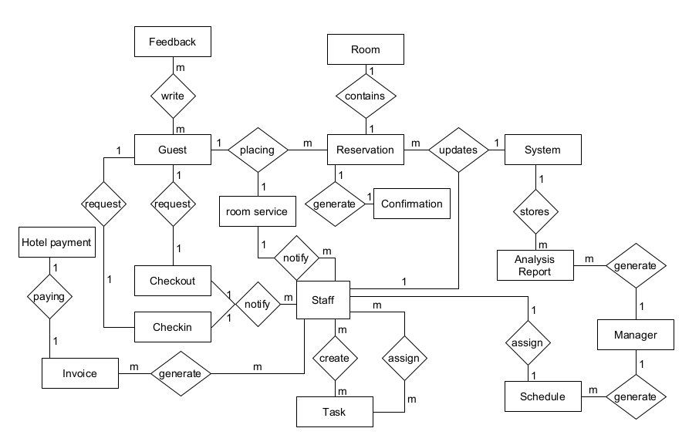

**4.2 Data Dictionary for Check Inn #1 Hotel Management System**

| **Data Element** | **Description** | **Composition or Data Type** | **Length** | **Values** |
| --- | --- | --- | --- | --- |
| **GuestID** | **Unique identifier for each guest.** | **Integer** | **Up to 10 digits** | **Positive integers** |
| **FirstName** | **Guest's first name.** | **String** | **1-50 characters** | **Alphabetic characters only** |
| **LastName** | **Guest's last name.** | **String** | **1-50 characters** | **Alphabetic characters only** |
| **Email** | **Guest's email address.** | **String** | **5-100 characters** | **Standard email format** |
| **PhoneNumber** | **Guest's contact phone number.** | **String** | **10-15 characters** | **Numeric, can include country code and area code** |
| **ReservationID** | **Unique identifier for each reservation.** | **Integer** | **Up to 10 digits** | **Positive integers** |
| **GuestID** | **Identifier linking to the Guest Profile.** | **Integer** | **Up to 10 digits** | **Positive integers** |
| **RoomID** | **Identifier for the reserved room.** | **Integer** | **Up to 10 digits** | **Positive integers** |
| **CheckInDate** | **Date and time when the guest is expected to check in.** | **DateTime** |  | **YYYY-MM-DD HH:MM:SS** |
| **CheckOutDate** | **Date and time when the guest is expected to check out.** | **DateTime** |  | **YYYY-MM-DD HH:MM:SS** |
| **Status** | **Current status of the reservation (e.g., Confirmed, Cancelled, Completed).** | **String** | **Up to 20 characters** | **["Confirmed", "Cancelled", "Completed"]** |
| **RoomID** | **Unique identifier for each room.** | **Integer** | **Up to 10 digits** | **Positive integers** |
| **RoomNumber** | **The room number as seen by guests and staff.** | **String** | **Up to 10 characters** |  |
| **RoomType** | **Category or type of room (e.g., Single, Double, Suite).** | **String** | **Up to 20 characters** |  |
| **OccupancyStatus** | **Indicates whether the room is occupied, available, or under maintenance.** | **String** | **Up to 20 characters** | **["Occupied", "Available", "Maintenance"]** |

### 

**4.3 Reports**

Check file “Report Specification.docx”

**4.4 Data acquisition, integrity, retention, and disposal**

**4.4.1 Data Acquisition**

Guest Data:

* Guests input their preferences and booking details through a client-facing interface, which could be a web or mobile application.
* Securely capture this data using AWS API Gateway and AWS Lambda to process the transactions and store them in AWS RDS.

Hotel Data:

* Hotel staff update inventory and other operational details, which must be accurate to ensure hotel operations.

Both hotel data and guest data would be stored in Amazon RDS.

**4.4.2 Data Integrity**

All sensitive and personal data from guests will be encrypted to protect the integrity of guest information. AWS Key Management Service will be utilized to manage encryption keys stored in AWS RDS. Access to hotel data will be restricted to ensure that only authorized hotel staff can access operational data.

**4.4.3 Data Retention**

Retention policies for guest data should comply with privacy laws and industry regulations. Lifecycle policies will be implemented while using AWS RDS.

**4.4.4 Data Disposal**

Both guest data and hotel data would be securely disposed when there is no longer needed or has exceeded its retention period. AWS RDS deletion operations will be utilized to ensure the data is unrecoverable once deleted. Flyway will be utilized to manage database versions and purge old records while ensuring that all dependencies are resolved to prevent data corruption.

**5. External interface requirements**

**5.1 User interfaces**

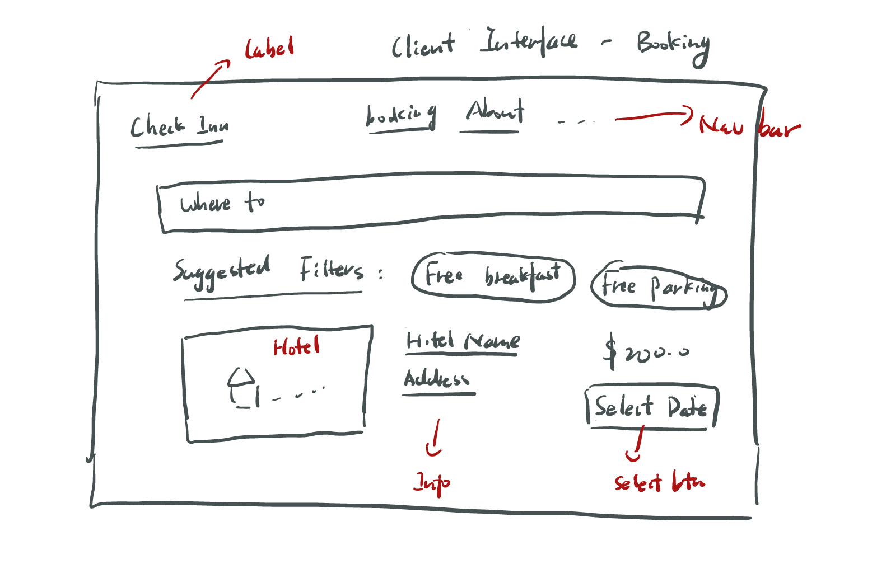

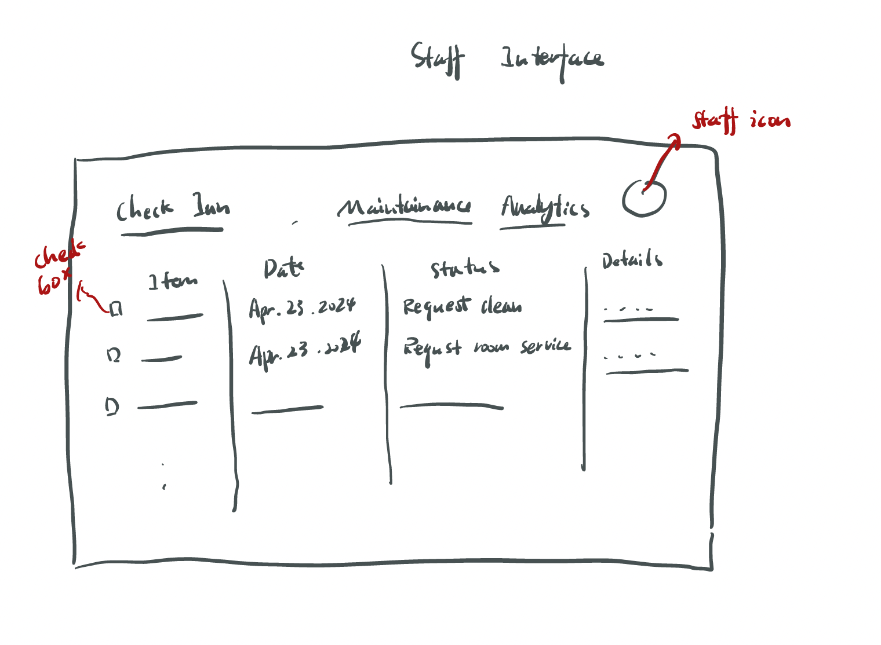

### **5.2 Communication Interfaces for the Check Inn #1 Hotel Management System**

#### 5.4.1. Confirmation Email Interface

**Functionality:**

* The system will automatically send a confirmation email to guests upon successful booking or reservation modification.

**Email Content:**

* Subject: Booking confirmation or update.
* Body: Includes guest name, reservation details (dates, room type, rate), and a unique reservation ID. It should also provide links to modify or cancel the booking and contact information for customer support.

**Message Formatting:**

* The email content will be formatted in HTML for a user-friendly layout that is responsive on various devices. It should align with the Check Inn brand's visual identity.

**Communication Security:**

* Sensitive information, like personal details, should be encrypted.
* The system must comply with privacy and data protection regulations PIPEDA, ensuring guest data is securely handled.

**Attachments:**

* No attachments will be included in the confirmation email to prevent security risks associated with email attachments.

#### 

#### **5.4.2. Invoice Email Interface**

**Functionality:**

* The system will send a detailed invoice to guests via email after their stay or upon checkout.

**Email Content:**

* Subject: Should indicate that the email contains an invoice for their recent stay.
* Body: Detailed breakdown of all charges (room rate, taxes, additional services), total amount, payment details, and a thank you message. It should also include an invitation to provide feedback or book future stays.

**Message Formatting:**

* The invoice will be formatted as an HTML email with an option to download the invoice as a PDF for guests' records.
* The design will be in line with the Check Inn brand guidelines, ensuring consistency and professionalism.

**Communication Security:**

* Transmission over secure SMTP with encryption to protect the confidentiality of the invoice details.
* Compliance with financial data transmission standards is required.

**Attachments:**

* A PDF version of the invoice will be attached for guest convenience. The system should ensure that the PDF is generated securely and is an accurate representation of the invoice content.

**Constraints:**

* The invoice email must include clear instructions for guests who need to dispute charges or require further clarification.
* The system should support the ability to resend invoices upon guest request.

**Data Transfer and Synchronization:**

* The system must ensure real-time accuracy of the data reflected in the confirmation and invoice emails, synchronizing with the hotel's booking and financial systems.

**6. Quality attributes**

**6.1 Usability**

* Ease of use: The system is designed to minimize cognitive effort by always clearly presenting the available actions.
* Error recovery: The introduction of "undo" functionality for most operations allows users to easily correct errors.

**6.2 Performance**

* Response Time: Complete 95% of transactions within 2 seconds, the system will provide immediate feedback for any operation expected to take more than 0.5 seconds.
* Uptime: The system architecture targets 99.9% uptime and is built with component redundancy to ensure uninterrupted service in the event of component failure

**6.3 Security**

* Data Encryption: Complementing encryption, the system utilizes comprehensive end-to-end encryption for all transmitted data to protect privacy and integrity. Encryption protocols are regularly evaluated to protect against new threats.

**6.x Other**

* Reliability: assessing reliability involves not only monitoring system uptime, but also the success rate of critical operations such as reservations and check-in/check-out procedures, with a target of 99.9% success rate. The disaster recovery strategy will be tested every two years.
* Maintainability and update downtime: Updates are designed to be rolled out with minimal or no downtime, and component hot-swapping is supported to minimize service interruptions.
* Data Privacy and Compliance: The ability to manage data consent preferences enables users to easily control their privacy settings for different data processing activities.
* Cross-platform compatibility: A suite of automated tests ensures forward compatibility across a wide range of devices, operating systems and browsers, including emerging technologies.

**7. Internationalization and Localization Requirements (Future Plan)**

The Check Inn #1 Hotel Management System will be designed to meet the diverse needs of an international clientele and workforce, ensuring that it is accessible and functional across different nations, cultures, and geographic locations. Key internationalization and localization requirements include:

* **Multi-Language Support**: The system must offer interfaces in multiple languages, including but not limited to English, French, Spanish, Mandarin, and Arabic, to cater to both guests and staff from various linguistic backgrounds. This includes language selection options for both the front-end user interface and back-end administrative operations.
* **Currency and Financial Localization**: The platform will support multiple currencies, enabling dynamic conversion rates for accurate billing and financial reporting. This includes compliance with local taxation laws, financial transaction norms, and integration with regional payment gateways.
* **Cultural Adaptation**: Interface designs, communication etiquettes, and service offerings will be culturally adaptive, respecting local customs, holidays, and social norms to avoid cultural insensitivities and enhance user experience.
* **Date, Time, and Numeric Formatting**: The system will adapt to local conventions for dates, times, numbers, addresses, and telephone numbers formatting, ensuring clarity and reducing the risk of misinterpretation.

**8. Other Requirements**

**Compliance and Standards:** The HMS will adhere to legal, regulatory, and financial compliance standards relevant to the hospitality industry. This includes ensuring all operations, financial transactions, and data handling practices are in strict compliance with applicable laws and standards.

**System Installation and Configuration:** Detailed guidelines for the installation, configuration, startup, and shutdown of the HMS will be provided, ensuring a smooth setup process for hotels. This includes customizable settings to match the specific operational needs and constraints of each hotel.

**Data Migration and System Integration:** As part of the transition from previous systems to the Check Inn #1 Hotel Management System, detailed requirements for data migration will be established, including the secure and accurate transfer of existing data.

**Training and Support:** Requirements for training development and delivery will be outlined to ensure that hotel staff can effectively use the new system. Ongoing support structures, including help desks and online resources, will be established to address any operational issues promptly.

**Sustainability Considerations:** The HMS will include features and functionalities aimed at supporting sustainability goals, such as energy and resource management tools, to help hotels reduce their environmental impact.

**Appendix A: Glossary for the Check Inn #1 Hotel Management System Project**

API: A set of protocols and tools for building software applications, specifying how software components should interact. In the context of the Check Inn #1 Hotel Management System, it enables various software components to communicate and work together efficiently.

Data Analytics: The science of analyzing raw data in order to make conclusions about that information. The Check Inn system uses data analytics to process information about guest preferences and behaviors, allowing for personalized service and strategic decision-making.

Digital Platform: An online framework that integrates different web-based tools to facilitate the operation of services, in this case, the Check Inn #1 Hotel Management System, which offers a suite of hotel management services online.

GUI (Graphical User Interface): A user interface that allows users to interact with electronic devices through graphical icons and visual indicators, as opposed to text-based interfaces, typed command labels, or text navigation. The Check Inn system provides a GUI for easy management and navigation.